# CMPT 365 Project 2

## Audio Compression

The wavefile reader uses a Java Wav File IO class made by A.Greensted.

The Huffman encoding algorithm is made by Marvin Jason.

## Image Compression

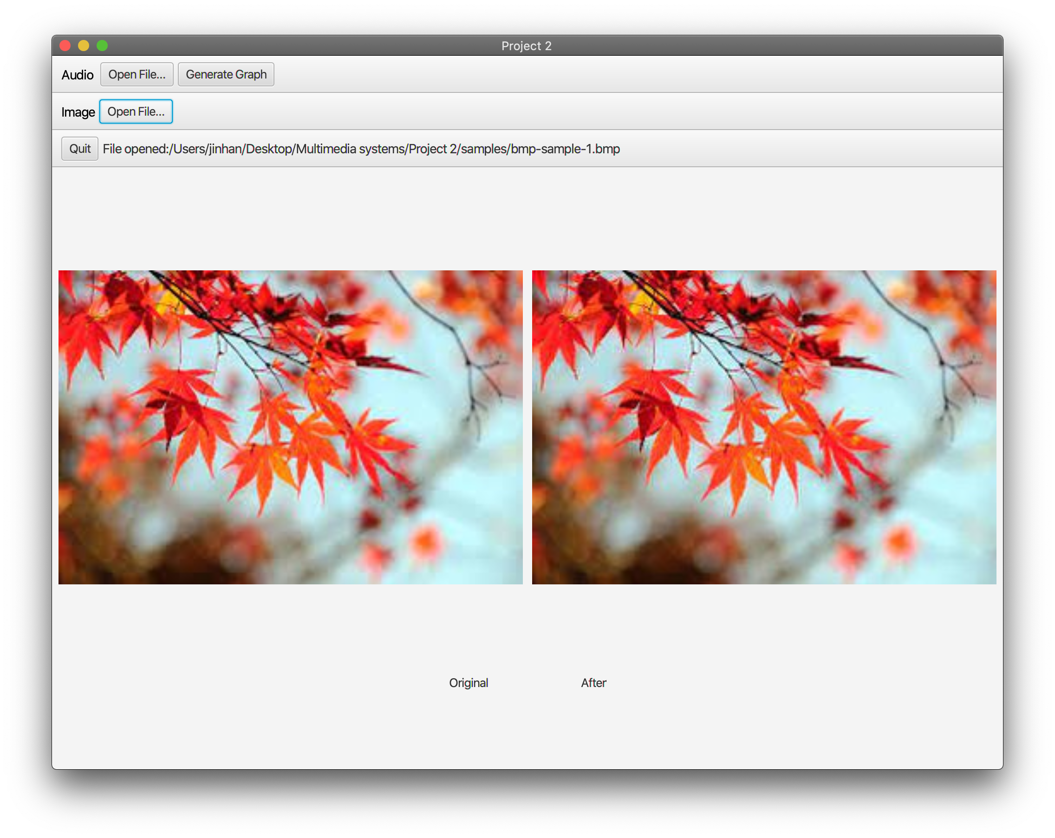

Before and After

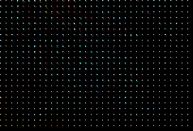

Quantized Result

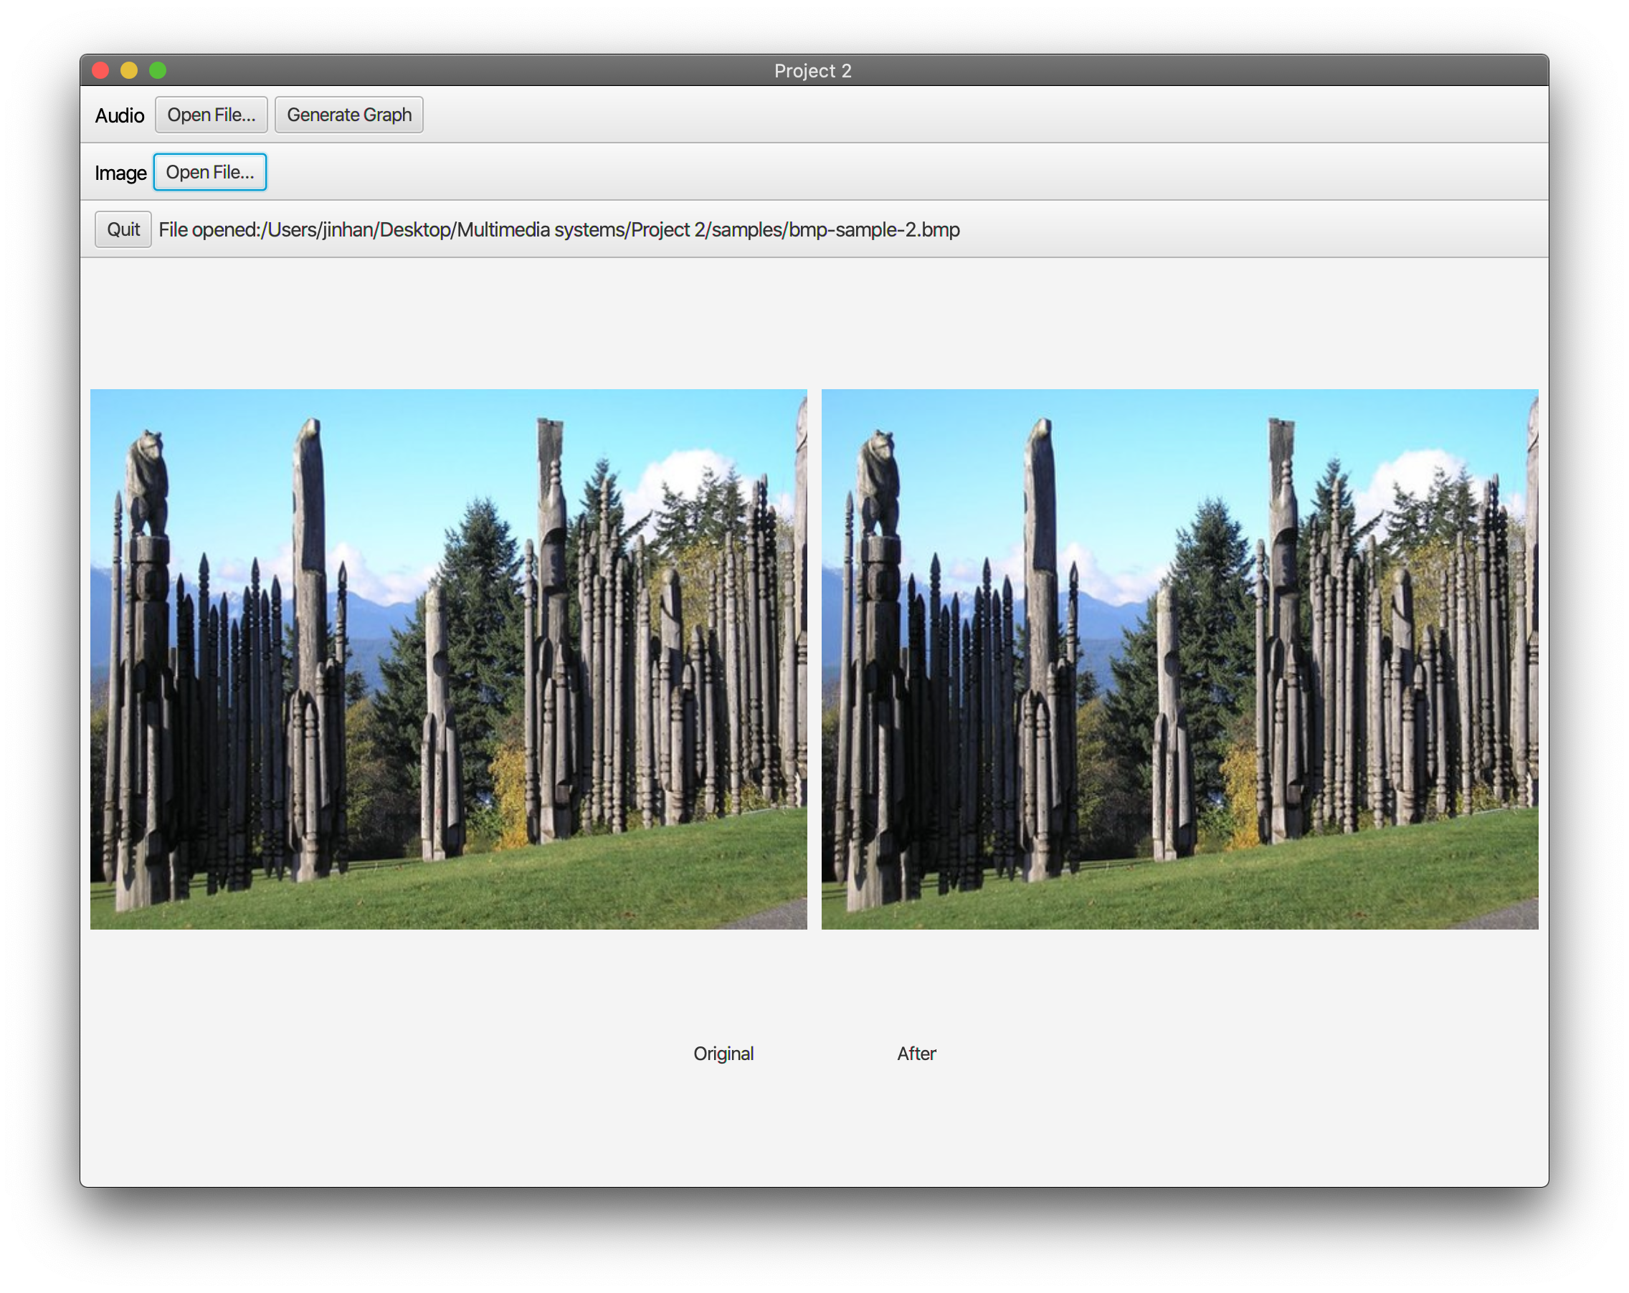

Before and After

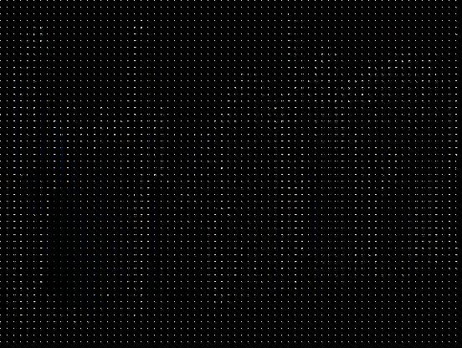

Quantized Result

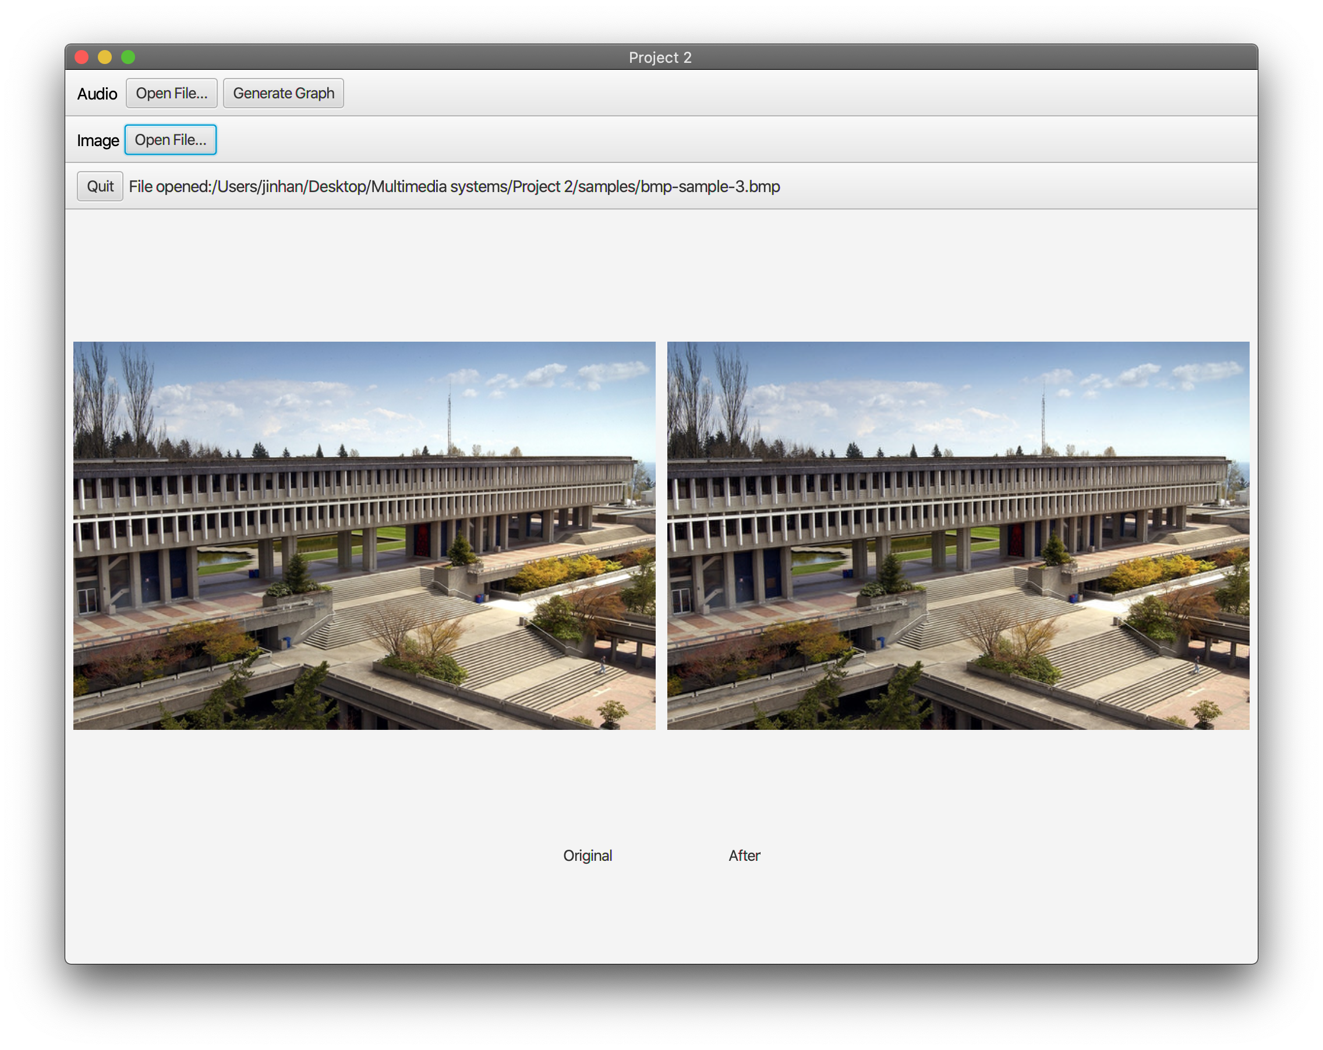

Before and After

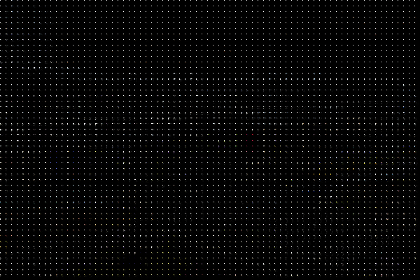

Quantized Result

The quantized image has all energy concentrated to the upper left of each 8x8 grid. The resulting image has visible 8x8 blocks and sharp transitions between each block.

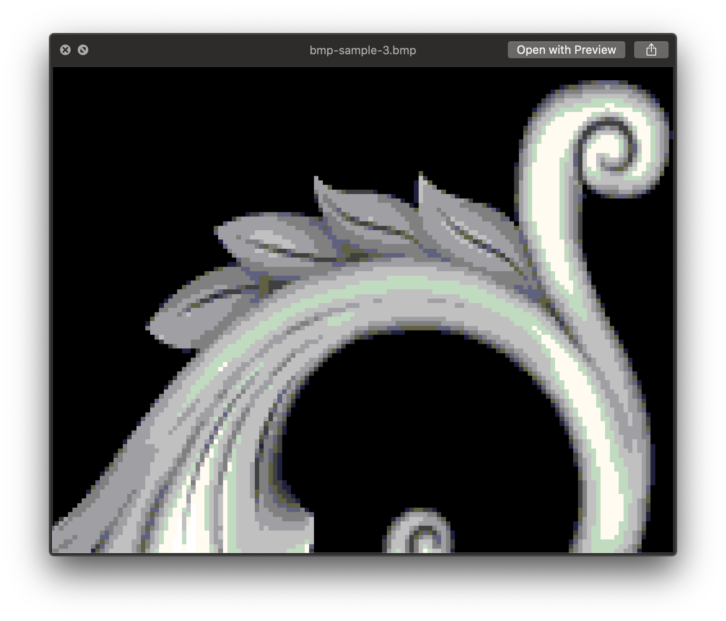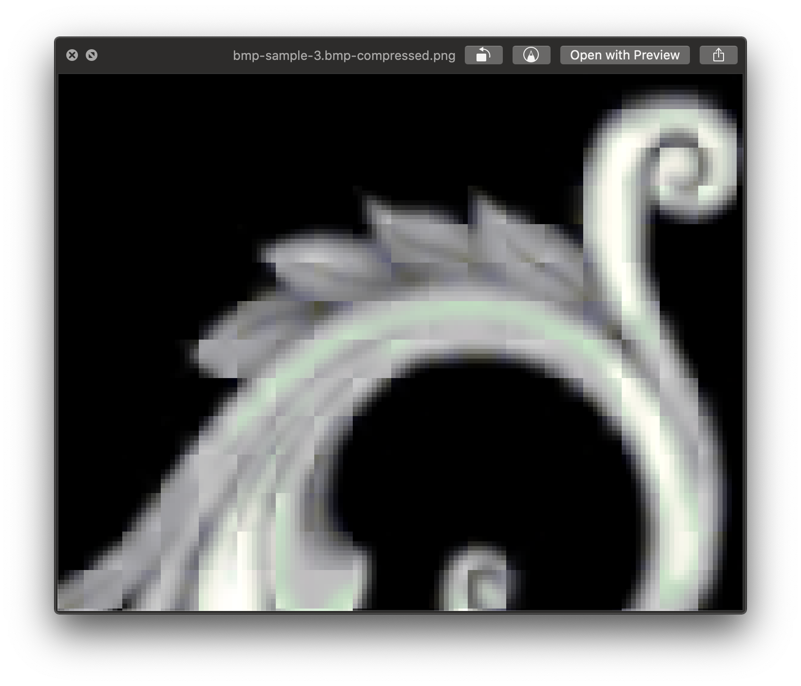

Before and After

For this assignment, all code have hard-coded matrix properties, meaning they will only apply to images with height and width that are multiples of 8. It would be possible to optimize the approach to introduce a general-use algorithm for images of any dimension. In terms of compression, it’s also possible to apply Huffman encoding to further suppress file size, but that is not part of the project requirement.

The program runs on O(N) time as conversion is done on each pixel. It executes quickly with minimal delay on a modern laptop.

## **Submission Instruction**

Your submission should include four files. One is the report file, including the report content of two questions. The second and third one should be two videos illustrating your programs and the results of all sample cases (Details are shown below). The last one is a .zip file, including all your source code and executive files. The .zip file should be organized as follows

<your-submission>

|-- <your-sfu-id>.pdf

|-- <your-sfu-id>-q1.mp4

|-- <your-sfu-id>-q2.mp4

\-- <your-sfu-id>.zip

|-- q1

|     |-- src

|     \-- release

\-- q2

      |-- src

      \-- release

The <src> directory should include your source code of the Q1 or Q2 question, and the

<release> directory should include your executive files, including all other libraries

required to run this program.

### **Q1**

1. (10 pts) The compression results of running all three sample cases. Results should include sizes of both the original file and the compressed file, as well as the compression rate.

2. (10 pts) Discuss the compression rate as compared to the FLAC coding and the

potential reasons, as well as any potential improvement.

## Reference:

https://github.com/marvinjason/HuffmanCoding

http://www.labbookpages.co.uk/audio/javaWavFiles.html

http://soundfile.sapp.org/doc/WaveFormat/

https://monkeysaudio.com/theory.html

https://docs.oracle.com/javase/8/javafx/api/javafx/scene/image/PixelWriter.html

https://docs.oracle.com/javase/tutorial/java/nutsandbolts/datatypes.html

https://www.geeksforgeeks.org/stringbuilder-class-in-java-with-examples/

https://stackoverflow.com/questions/5263187/print-an-integer-in-binary-format-in-java#5263199

https://stackoverflow.com/questions/36782231/printing-a-java-map-mapstring-object-how

https://stackoverflow.com/questions/59246658/how-do-i-access-a-specific-index-in-a-string-in-java

https://zetcode.com/java/filesize/